Software Requirements Specification

For

Your App Name
Version 0.4
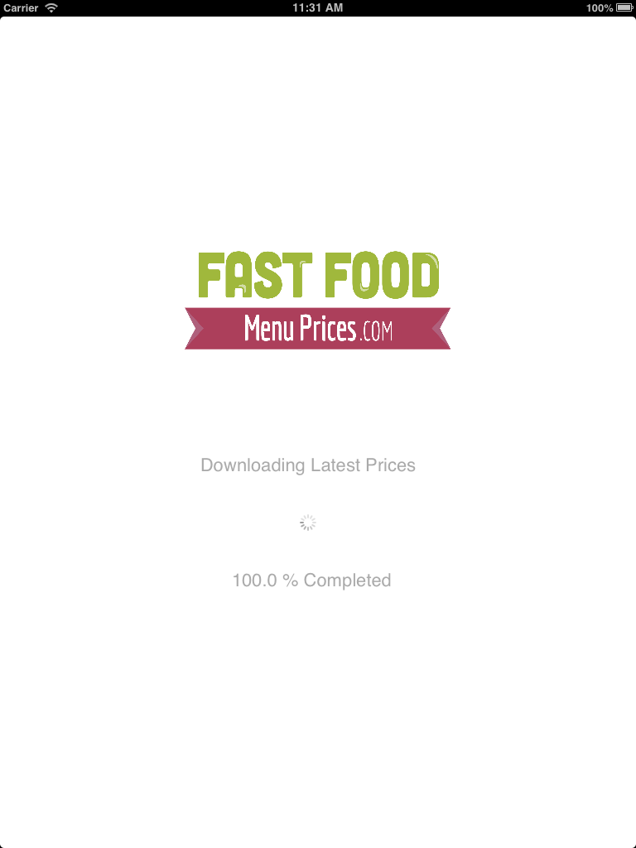
Prepared by Your Name

← Replace these screen shots with PSD

Wednesday, October 9, 2013

Table of Contents

Table of Contents
Revision History
- Introduction
  - Purpose
  - Intended Audience and Reading Suggestions
  - Product Scope
  - Document Definitions
  - References
  - Product Perspective
  - Product Functions
  - User Classes and Characteristics

Revision History
Name | Date | Reason For Changes | Version
Christopher Miller | 04/02/2014 | Initial/Introductory Draft Completed | 0.1
Your Name |  | Validation 1 of Initial/Introductory Draft | 0.2
Christopher Miller | 10/07/2013 | Update 1 to Document/Specification | 0.3
Your Name |  | Validation of Update 1 of SRS | 0.4

Introduction

Purpose
The purpose of this software specification document is to define the components/requirements for creating an iOS version of Your App Name (YAN? - App Acronym). This document will outline all of the necessary functions to complete the App Acronym application. The design of the application is not purposed in this document.

Intended Audience and Reading Suggestions
The intended audience for this document is Your Name, and Android/iOS Operator (Christopher Miller the development advisor).

This SRS document will be broken up into the following sections: Project Description, Glossary, System Features, External Interface Requirements, and Non Functional Requirements.

Product Scope
The App Acronym project’s resources are managed at your_content_website.com. This site is to be accessed by users for day-to-day app/service usage.

Document Definitions
Application Archive | The executable that runs on a registered iPhone/iPad
API | App Acronym Application Programming Interface with Cloud Endpoints
Device | The mobile device that runs on the system (e.g, iPhone/iPad)
iOS | Interim Operation System (non-admitting)
IDE | Integrated Development Environment (i.e., Eclipse, Visual Studio, etc.)
GIT | A revision control and source code management (SCM) system with an emphasis on speed.
FFM | Your App Name – The application in development
App Acronym | The Your App Name Web Site/Resource
Functional Requirement | Defines a function of a system or its component
Non-Functional Requirement | Specifies a criteria that shall be used to judge the system operation
Patron | A customer that views app content of their preference
SDK | Software Development Kit (as in iOS SDK)
SRS | Software Requirements Specification
UDID | Unique Device Identifier
UI | User Interface

References

All devices that will use the application, outside of the App Store installations will need to have their device’s UDID listed below for registration (and testing purposes):

Christopher Miller’s iPhone | XXXXXXXXXXXXXXXXXXXXXXXXXXXXX69a

Acquire Apple UDID: https://github.com/the-mac/iOS/blob/master/UDID.md

The system will use Google Analytics and Google Admob. The following are the ids for the respective web services:

Analytics Tracking ID | XXXXXXXXXX-3
Admob Unit ID | xxxxxxxxxxxxxe2

Overall Description

Product Perspective
This iOS application is the third client component of the Your App Name System. The App Acronym iOS app gains its origin from the site (your_content_website.com [github.com?]), and the Android client implementations (as well as popular demand). The App Acronym site has an interface in the form of a Web API (Cloud Endpoints), which holds all item data, and allows for immediate correspondence with the App Acronym team.
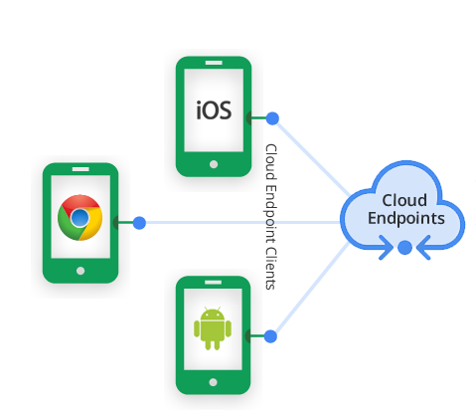

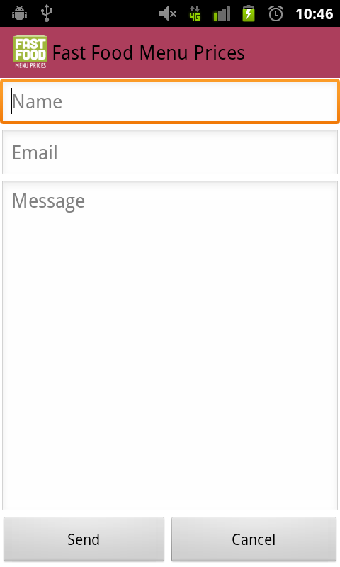
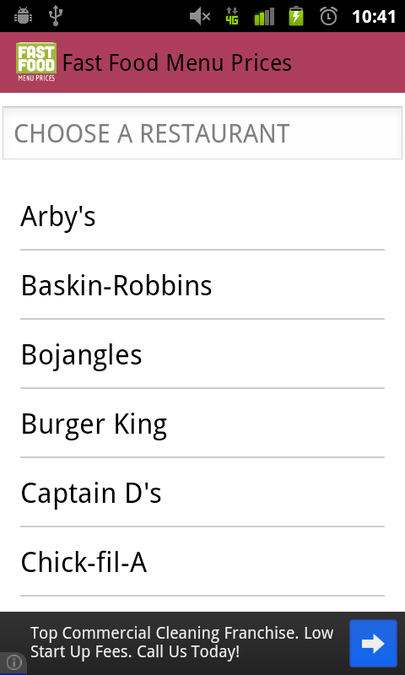

Product Functions
A Patron is given a list of items to select from and has the option to view each item’s current content. The Patron can also contact the App Acronym team for questions or suggestions through the email screen. These actions get accomplished through online resources.

User Classes and Characteristics
Patron | A Patron is a customer that views items of their preference.  Patrons will sometimes view multiple items. All Patrons have access to the items from any device. A Patron shall be able to make comments about the service, and ask questions as well.

